Ideation Phase
Define the Problem Statements

Date | 19 September 2022
Team ID | PNT2022TMID27279
Project Name | Project – A Novel Method for Handwritten Digit Recognition System
Maximum Marks | 2 Marks

Customer Problem Statement Template:
Create a problem statement to understand your customer's point of view. The Customer Problem Statement template helps you focus on what matters to create experiences people will love.
A well-articulated customer problem statement allows you and your team to find the ideal solution for the challenges your customers face. Throughout the process, you’ll also be able to empathize with your customers, which helps you better understand how they perceive your product or service.
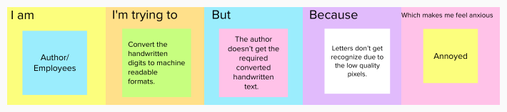

Problem Statement (PS) | I am (Customer) | I’m trying to | But | Because | Which makes me feel
PS-1 | Author | Helps to transform the writing in the paper to a text document format. | The author doesn’t get the required converted handwritten text. | Letters don’t get recognize due to the low quality pixels. | Annoyed
PS-2 | Employees | Convert the handwritten digits to machine readable formats. | The machine readable format may not be similar to handwritten text. | Due to the incorrect writing ,the data cannot be saved to the database. | Annoyed

